COMP213 Machine Learning and AI
Introduction
Machine learning (ML) agents have become increasing important and integral components in various fields of research, from robotics to finance to games showing their ability to adapt and to learn from different environments. Studies by Sutton and Barto (2018) in reinforcement learning have shown the adaptability of machine learning and how it can evolve and change in specific environments, but there remains a gap in understanding how different types of ML agents interact with a range of differing environments. This essay aims to address the research gap by testing how ML agents interact with different environments across different domains, we seek to measure the factors related to the adaptability and performance of ML agents in diverse environments and identify the limitations and challenges that these ML agents might face in these environments to provide valuable insight into enhancing the robustness of ML algorithms. Through this we will gain a deep understanding of the dynamic between ML agents and their environments.
Background
The field of Machine Learning (ML) has had a massive growth in recent years, caused by exponential growth in advancements of algorithms, computing power and the amount of data and testing that we now have available to us. The main cause of all this progress is because of the Machine Learning agents which are intelligent systems capable of learning from previous versions of themselves. Using a variety of algorithms such as Reinforcement Learning (RL), deep learning and evolutionary algorithms to adapt to the environments that the ML Agents are placed into.
Reinforcement Learning has emerged as a very impressive and important training method for ML agents providing an efficient way to adapt to the diverse environments that agents using this algorithm can be placed into, some important historical developments of machine learning include the introduction of Q-Learning by Watkins and Dayan (1992) and the advancement of techniques in this area such as deep learning proposed by Mnih et al. (2015) and double deep learning, Deep learning algorithms can be described as deep neural networks (DNNs) and have simplified various ML tasks such as natural language processing and robotics, Double Deep learning Hado van Hasselt (2010) is proposed to improve the poor performance that Q learning provides caused by overestimation of action values, Double deep learning instead underestimates action values. Another example of the exponential growth that has been seen in the Machine Learning field is the introduction of Evolutionary Algorithms, which provides effective solutions to computationally difficult optimization problems, Alfredo Milani (2020) by using inspiration from biological evolution to optimize agents using mutation, crossover, and selection.
When it comes to which algorithms can be used, Reinforcement Learning (RL) and Deep Learning can be used effectively to observe the performance of our agents in foreign environments, these algorithms will enable agents to learn from the interactions with the environment and the most important part which is them being able to adapt to the situation at hand and make informed decisions based on the inputs.
Debate persists on the scalability and efficiency problems around ML algorithms and more importantly the ethical issues that are faced when it comes to ML, and the real-world deployment on of autonomous systems Amodei, Dario et al. (2016) lists some of the risks that we can define as “Avoiding Negative Side Effects, Avoiding Reward Hacking, Scalable Oversight and Safe Exploration”, in the generalisation of a cleaning robot they discuss how we need to ensure the cleaning robot does not disturb the environment, wont game its reward function, respects aspects of the objective and does not make any exploratory moves with bad repercussions. Understanding the complexity of these issues that are faced are crucial when it comes to discussing the interactions between ML agents and their environments so we can understand the subject properly as it is explored in this paper.
Environment
The environment created was based on the unity ML-agent package base environment which consists of a plane, cube (Agent) and a yellow sphere(goal) to adapt this environment and provide more of a challenge a purple seeker sphere was added as can be seen fig.1 all three environments used are identical, and they have invisible “Walls” running round the outside of the plane that the tests are taken on, all three of the environments were made prefabs which means that any part of the environment can be edited at once as each of the three environments have nine instances throughout the project.
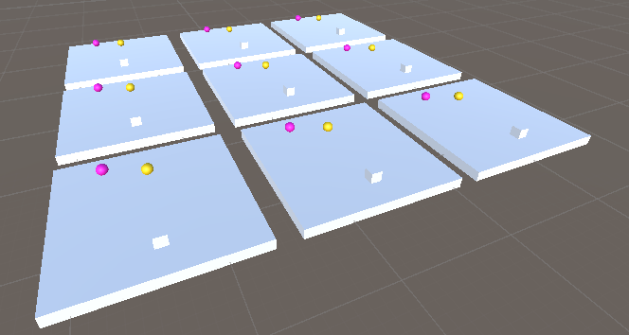
Method
This paper aims to identify which agent performs best in the given environment when the parameters such as the reward structure, environment obstacles and exploration factor are changed and how this affects the performance of the agent. Using the Unity ML-Agents package running a very basic virtual environment , the seeker moves in a random pattern throughout the test and is added to the environment as an obstacle to the agent, the agents job is to reach the goal which will then give it a score of one, hitting the barriers that surround the plane or hitting the seeker gives a score of negative one, this setup was made through the Unity tutorial and some video tutorials made by CodeMonkey, three agents were made initially the first was made to specifically go to the goal and maximise the amount of points that could be scored by taking the shortest route possible to the goal this agent was called the “Greedy” agent. The second agent made was the “Avoider” agent and its job is to make it to the goal but to avoid the seeker at the same time, the third and final agent is named the “Random” agent and its job is to move randomly about the environment this is implemented as a baseline for comparison when we take into account the results of the other agents so while it does not demonstrate learning behaviour it still serves useful in the project.

http://incompleteideas.net/book/RLbook2020.pdf
https://link.springer.com/article/10.1007/BF00992698
https://www.proquest.com/docview/1661579491?pq-origsite=primo&sourcetype=Scholarly%20Journals
https://papers.nips.cc/paper_files/paper/2010/file/091d584fced301b442654dd8c23b3fc9-Paper.pdf
https://mdpi-res.com/bookfiles/book/3184/Evolutionary_Algorithms_in_Intelligent_Systems.pdf?v=1708985026
https://arxiv.org/pdf/1606.06565.pdf
//github.com/Unity-Technologies/ml-agents/blob/develop/docs/Learning-Environment-Create-New.md

